ER Model

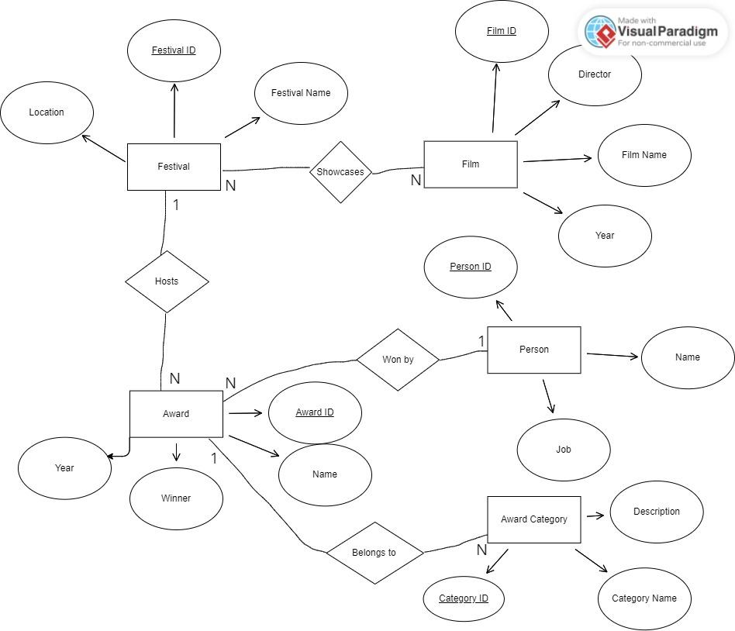Relational Schema

**Festival:**

Festival (FestivalID (PK), Name, Location,)

One Film Festival can have many Awards (1:N).

Festival_Hosts_Award (

FestivalID (PK, FK REF Festival.FestivalID),

AwardID (PK, FK REF Award.AwardID)

)

One Film Festival can showcase many Films, and one Film can be showcased in multiple Film Festivals (N:M).

Festival_Showcases_Film (

FestivalID (PK, FK REF Festival.FestivalID),

FilmID (PK, FK REF Film.FilmID) )

| **Attributes** | **Data type** | **Constraints** | **Description** |
| --- | --- | --- | --- |
| festivalID | INT | NOT NULL | The unique identifier for the festival |
| Location | VARCHAR(100) | NOT NULL | The area of where the festival is located. |
| festivalName | VARCHAR(100) | NOT NULL | The name of the event. |

**Film:**

Film ( FilmID (PK), Director, FilmName, Year)

| **Attributes** | **Data type** | **Constraints** | **Description** |
| --- | --- | --- | --- |
| FilmID | INT | NOT NULL | The unique identifier for the film |
| Director | VARCHAR(100) | NOT NULL | The name of the films director |
| filmName | VARCHAR(100) | NOT NULL | The name of the film. |
| Year | INT | NOT NULL | The year the film was released. |

**Award:**

Award ( AwardID (PK), Name, Winner, Year)

One Award belongs to one Award Category, but one Award Category can have multiple Awards (1:N).

Award_BelongsTo_Category (

AwardID ( PK, FK REF Award.AwardID),

categoryID ( PK, REF awardCategory.categoryID)

)

| **Attributes** | **Data type** | **Constraints** | **Description** |
| --- | --- | --- | --- |
| AwardID | INT | NOT NULL | The unique identifier for the award |
| Name | VARCHAR(100) | NOT NULL | Name of the award being presented |
| Winner | VARCHAR(100) | NOT NULL | Winner of award |
| Year | INT | NOT NULL | Year of award winner |

**Award Category:**

AwardCategory ( CategoryID, categoryName, Description)

| **Attributes** | **Data type** | **Constraints** | **Description** |
| --- | --- | --- | --- |
| categoryID | INT | NOT NULL | The unique identifier for the category |
| categoryName | VARCHAR(100) | NOT NULL | Name of the award category |
| Description | VARCHAR(100) | NULL | This is a little description of the awards category |

**Person:**

Person ( personID, Name, Job)

One Award can be won by multiple Persons, and one Person can win multiple Awards (N:N).

Award_WonBy_Person (

AwardID (PK, FK REF Award.AwardID),

PersonID (PK, FK REF Person.PersonID)

)

| **Attributes** | **Data type** | **Constraints** | **Description** |
| --- | --- | --- | --- |
| personID | INT | NOT NULL | The unique identifier for the person |
| Name | VARCHAR(100) | NOT NULL | Name of the award person |
| Job | VARCHAR(100) | NOT NULL | Occupation of the person |